RESUME
Name: R.Aswin 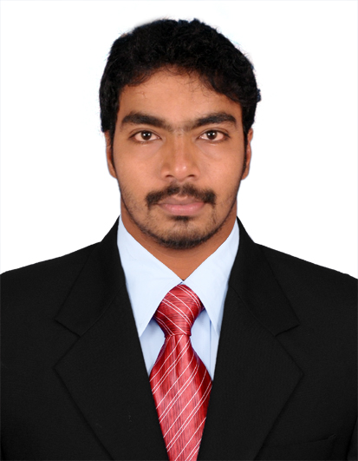
E-mail id: ashwin91y@gmail.com
Mobile: +91-9976062787,+91-9629978180 1/38 East street, aanaimangalam,
Kilvelur, Nagapattinam dist,
Tamil Nadu State, PIN- 611104
India

Career Objective:
Continue to learn, enrich my skills, contribute to the organization and grow with it.

Educational Qualifications
- B.TECH Petrochemical technology from Periyar Maniammai university, Thanjavur, Completed in the year of 2012 with an aggregate of 8.52(CGPA).
- H.S.C from Veludaiyar Higher Secondary School, Thiruvarur, completed in the year 2008 with an aggregate of 57%.
- S.S.L.C from Modern Matriculation Higher Secondary School, Nagapattinam, completed in the year 2006 with an aggregate of 60%.

Working Experience:
- Worked as a engineer trainee in Technical service department From November 2012 – March 2013 At Young Buhmwoo india private limited , Mambakkam sipcot, Sriperampudhur, Chennai.
- Working as Engineering Management trainee in Southern Petrochemical Industries Corporation limited (SPIC) , Tuticorin ,From march 2013 to September 2014
- Currently Designated as Assistant manager- production in Southern petrochemicals industries corporation limited (SPIC). Tuticorin
An Overview
- A dynamic professional with 3 Years and 7 months of experience in Commissioning, Operation, Process control and Plant DCS Operation of Ammonia and Urea Fertilizer Unit and Utilities.

- Adroit in managing overall operations and plant performance activities with a view to enhance the operational efficiency of Production and eliminating obsolescence.

- Expertise in Operating Static and Rotary equipments, Utilities, Shutdown Planning, Quality Monitoring, troubleshooting, Cost effectiveness, Safety, and Environment management.

Areas of Expertise:
- Managing the Shift operations & DCS operations to identify any deviations in the process parameters from the design/set values and take appropriate actions.
- Experience in Handling the ICI Steam reforming Ammonia process and Mitsui Toatsu improved C Urea process plant and utilities plant.
- Experience As a Safety Coordinator in Shutdown and Turnaround Period.
- Experience in Handling the Reactor Titanium lining renewal job in Turn Around Period.
- Experience in commissioning the heat exchangers ,Pressure vessel ,High pressure absorbers.
- Experience in Handling rotary equipments such as pumps, fan, blower, agitator, dryer, cooler, conveyors, compressors, turbines and static equipments such as boiler, pressure vessels, reactors, exchangers, heaters, storage tanks, cooling towers, pipelines and valves
- Expertise in Operation of Reformers, Hydrofining and Utilities including Demineralization Plant, Boilers, cooling water treatment, pressure swing absorbers and Steam turbines.
- Process control and Quality monitoring for improved productivity and zero production loss.
- Carrying out and ensuring safe, efficient and timely start up, operation and shutdown activities
- Expertise in Inspecting the thickness of the Process & utilities Pile lines & Pressure vessels Through Ultrasonic Test method.
- Coordinating effectively with other plants and departments and strict adherence to SOP
- Having full acquaintance with maintenance intervention and planning requirements
- Handling emergencies of the unit, trouble shooting problems and to take remedial actions
- Maintaining record of various of environmental releases, identify occupational hazards, risk assessment and control in the plant
- Coordinating with field operators to ensure proper functioning of the systems
- Identifying areas of obstruction / breakdowns and taking steps to rectify the equipments through application of trouble shooting tool.
- Experience in conducting an internal ISO audit as a part of team member.

Skills
- DCS operation with expertise in Centum XL & PLC SCADA
- Boiler panel operation and Urea panel operation
- Working Knowledge in Activ (Integrated Maintenance Management System) & OPTIMAT (Materials Management system )
- Well versed with MS Office Suit (Word, Excel & PowerPoint) and Internet Applications.
Health, Safety & Environment
- Create new and better way of production controlling pollution, conserving resources and making the processes safer.
- Actively promoting excellence in HSE
- Imparting and insisting Safety at work providing high priority for Better housekeeping
- Ensuring “ zero accident” work place by complying with company occupation health and safety policies
- Effectively ensuring “zero Discharge” of effluents by various effluent treatment methods and reutilization.

Project Name : STUDY APPROACH ON DESULFURIZATION OF SOUR CRUDE OIL
Project Description:
Desulfurizing the sour Crude oil at the Group gathering station by caustic dosing method (NaOH) From the Various oil wells In ONGC (Oil and natural gas corporation limited),At (Narimanam) Karaikkal.

In plant Training & Certification course:
- I Had undergone in-plant training for 10 days at Chennai petroleum corporation limited (CPCL) at Panangudi, And for 7 days in-plant Training At Oil And Natural Gas corporation limited (ONGC) in Narimanam GGS at karaikkal.During III and IV semester.
- I Had Undergone in-plant training for 10 days at Southern petrochemical corporation limited(SPIC) at tuticorin. During VI semester.
- I had completed the NEBOSH International General Certificate Safety training Course.

Personal Profile:
Father’s Name : N. Raja
Mother’s Name : R. Mallika
Sex : Male.
Date of Birth : 22-07-1991.
Nationality : Indian.
Languages Known : English, Tamil.
Current CTC : 5.25 LPA
Passport no : M 4149187
Skype Id : aswinraja22

Professional References:
Mr.A.Prakash
Senior manager ,Production
Tuticorin Alkalis and chemicals limied
SPIC complex,Tuticorin
Email: prakash.anush@yahoo.co.in
Mobile: +919789182801

Mr R.Sitaraman
Deputy manager, Urea production
Southern Petrochemical industries corporation limited, Tuticorin
Mobile no: +91 9442077957

Declaration:
I hereby declare that the above written particulars are true to the best of my knowledge and confidence.
Place: Tuticorin R. Aswin

